# **16. VLANS: PART 1**

## **WHAT IS A LAN?**

* A **LAN (Local Area Network)** is a **single BROADCAST DOMAIN**, including all devices in that broadcast domain.

### **BROADCAST DOMAINS**

* A **BROADCAST DOMAIN** is the group of devices that receive a **BROADCAST FRAME** (Destination MAC: FFFF.FFFF.FFFF) sent by any one of the members.

#### **Image of LAN with FOUR BROADCAST DOMAINS (192.168.1.0 / 24):**

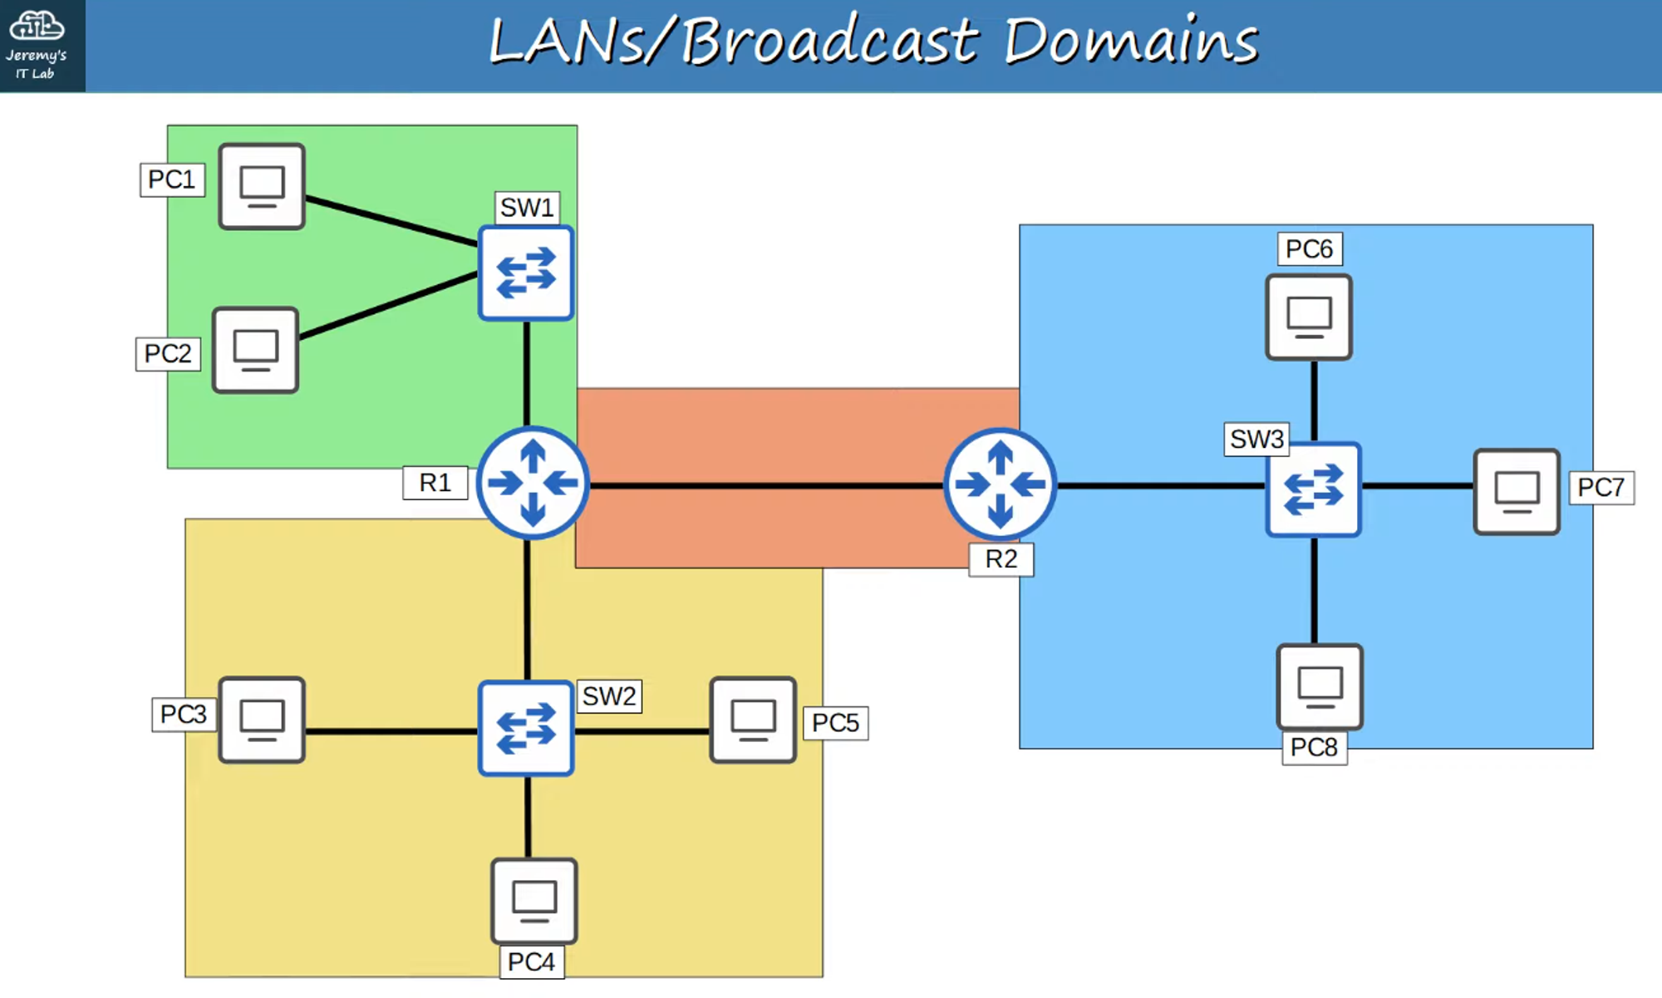

### **Performance Impact of Broadcast Domains**

* **Unnecessary BROADCAST traffic** can reduce network performance.

#### **Image of BROADCAST FRAME flooding all subnets with unnecessary traffic:**

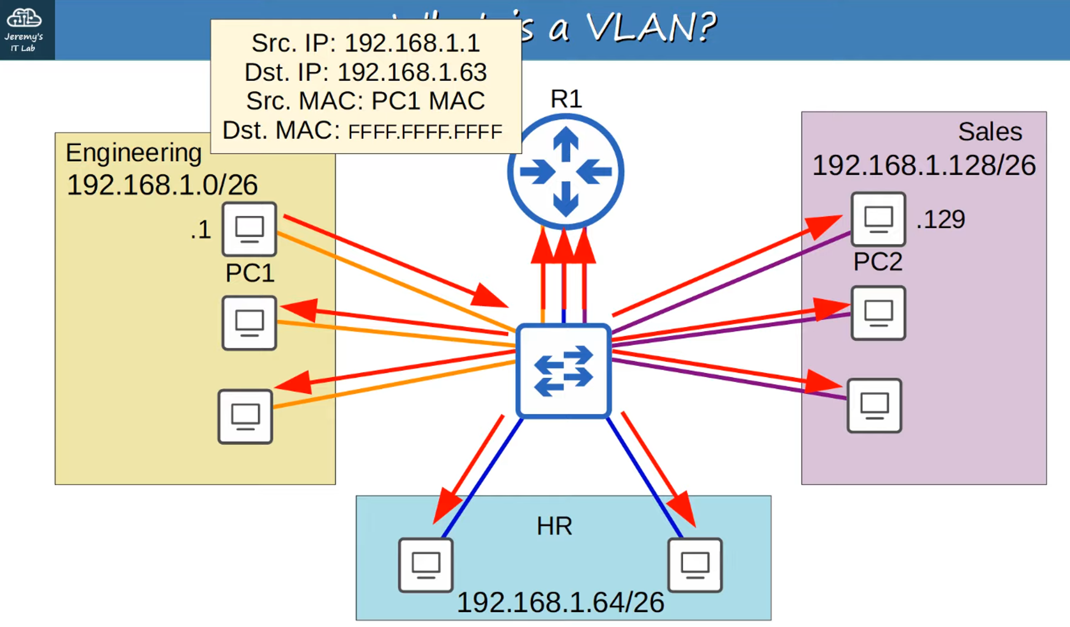

### **Security Implications of Broadcast Domains**

* Even within the same office, limiting access between devices is crucial.
* Security policies configured on a ROUTER/FIREWALL will have **no effect** if traffic does not pass through it.

#### **Image: LAN Security Issues - Direct Connection Bypassing Policies**

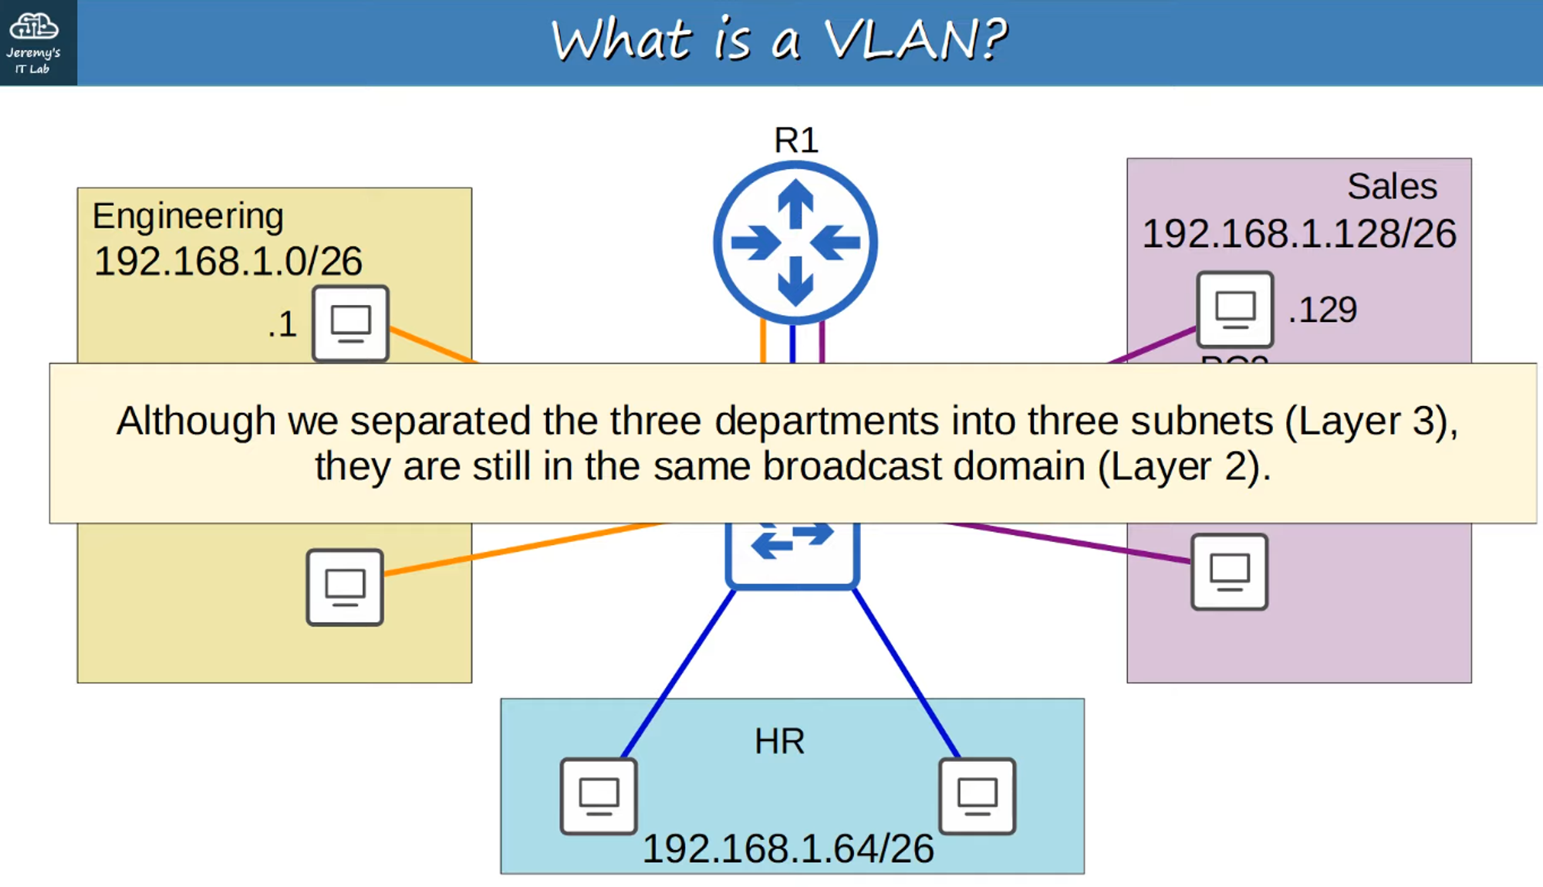

## **WHAT IS A VLAN?**

* **VLANs (Virtual Local Area Networks)**:
  + **Logically separate** end-hosts at **Layer 2**.
  + Configured on **Layer 2 SWITCHES** on a **per-interface** basis.
  + Any end-host connected to an interface is part of that VLAN.

## **PURPOSE OF VLANs**

### **Network Performance**

* **Reduce unnecessary BROADCAST traffic**, which prevents network congestion and improves network performance.

### **Network Security**

* By limiting **BROADCAST** and **unknown UNICAST traffic**, VLANs improve security.
* Messages cannot be received by devices outside of the VLAN.

#### **Image of VLANs Limiting Broadcasts:**

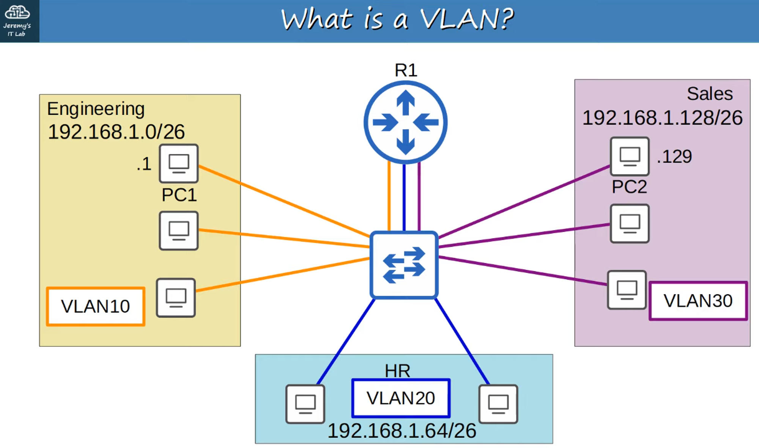

### **Traffic Separation**

* **SWITCHES do not forward traffic directly** between hosts in different VLANs.
* Traffic between VLANs must be routed through a **router** or **Layer 3 device**.

#### **Image: Inter-VLAN Traffic Routed Through R1:**

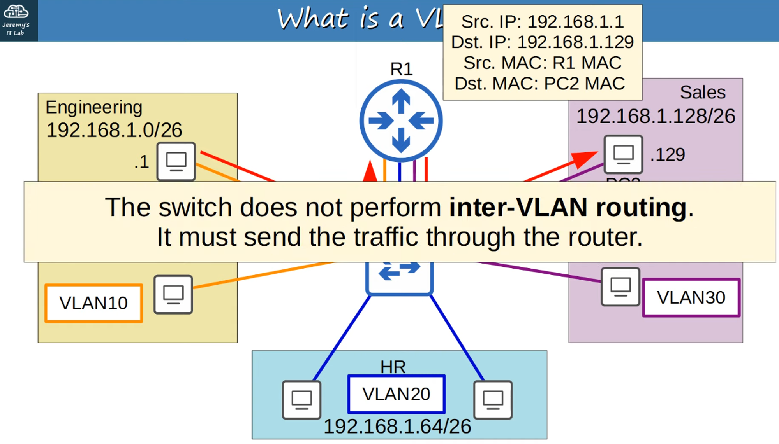

## **HOW TO CONFIGURE VLANS ON CISCO SWITCHES**

### **1. View Existing VLANs**

* Use #show vlan brief to view existing VLANs and interfaces assigned to each VLAN.

#### **Output Example:**

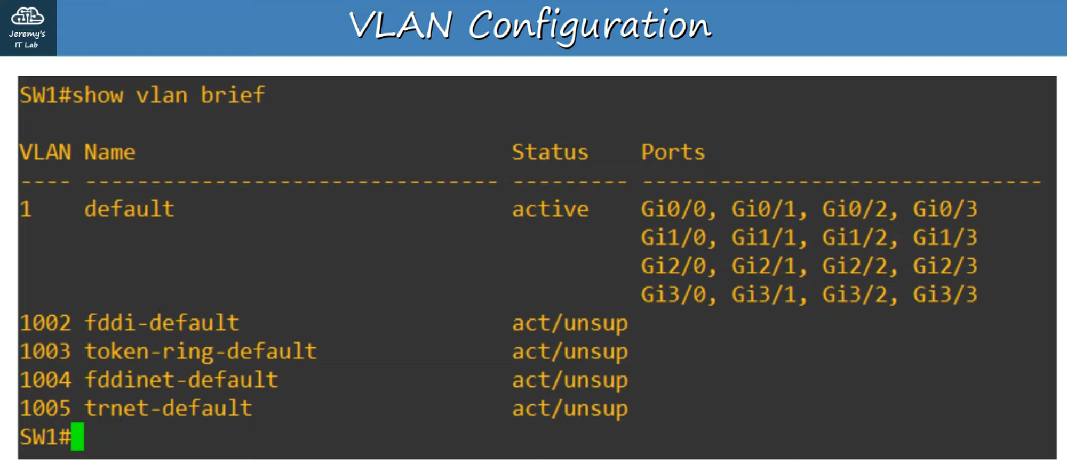

* By default:
  + VLANs 1 (Default) and 1002–1005 exist and **cannot be deleted** (total: 5 VLANs).

### **2. Assign Interfaces to a VLAN**

#### **Steps:**

1. Use the interface range command to select multiple interfaces simultaneously.
2. Use switchport mode access to set the interface as an **ACCESS PORT**.

#### **What is an Access Port?**

* An **ACCESS PORT** is a SWITCHPORT assigned to a **single VLAN**.
* It is typically used to connect end hosts like PCs.
* SWITCHPORTS carrying **multiple VLANs** are called **TRUNK PORTS** (covered in the next chapter).

1. Use switchport access vlan <VLAN_ID> to assign a VLAN to the port.

#### **Command Example:**

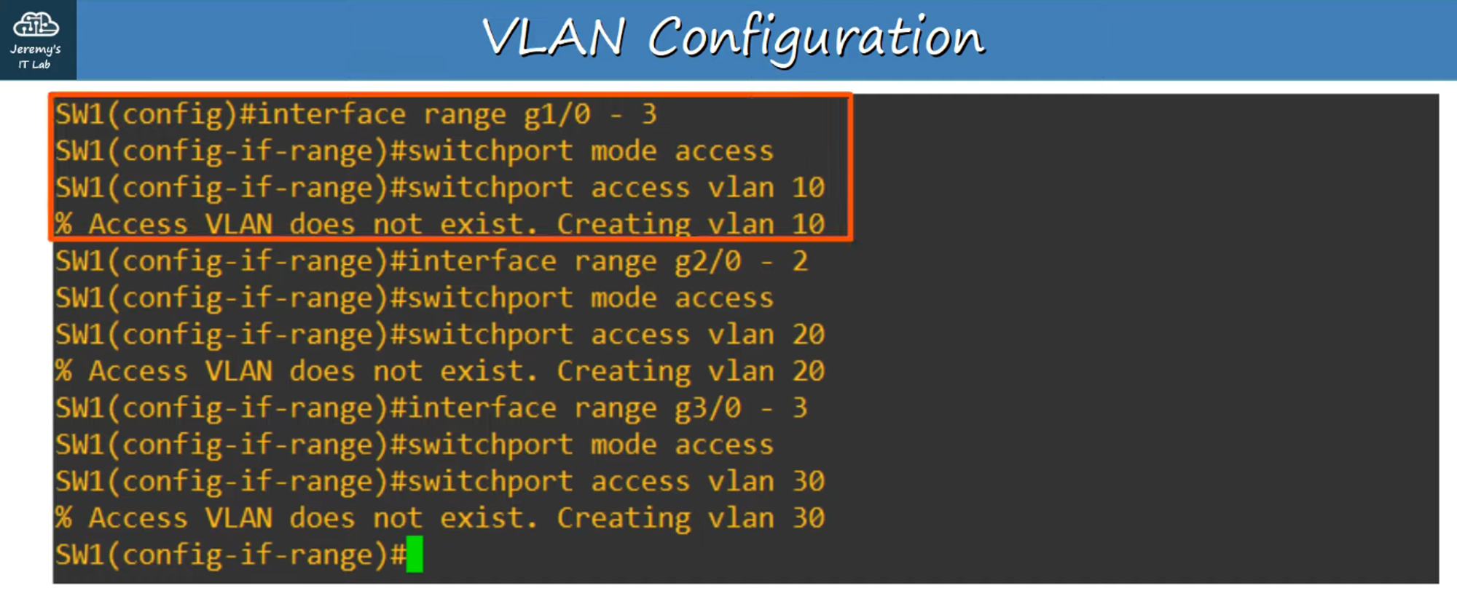

### **3. Configure VLANs on the Switch**

* Use #vlan <#> to enter **Configuration Mode** for a specific VLAN.
  + This command can also create a VLAN.
* Use #name <name> to configure a **name** for your VLAN.
* To verify the configuration, use #show vlan brief.

#### **Output Example:**

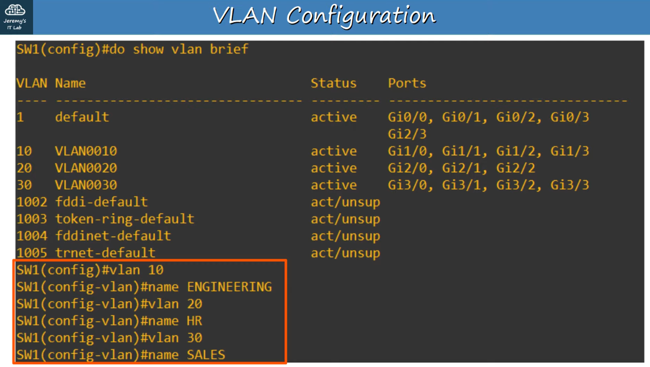

### **Testing VLAN Configuration**

* Example: Testing VLAN 10 with broadcast traffic.
* Pinging from PC1 using 255.255.255.255 (Destination: FFFF.FFFF.FFFF) will flood packets to **R1** and VLAN10 hosts only.

#### **Image of VLAN Broadcast Testing:**

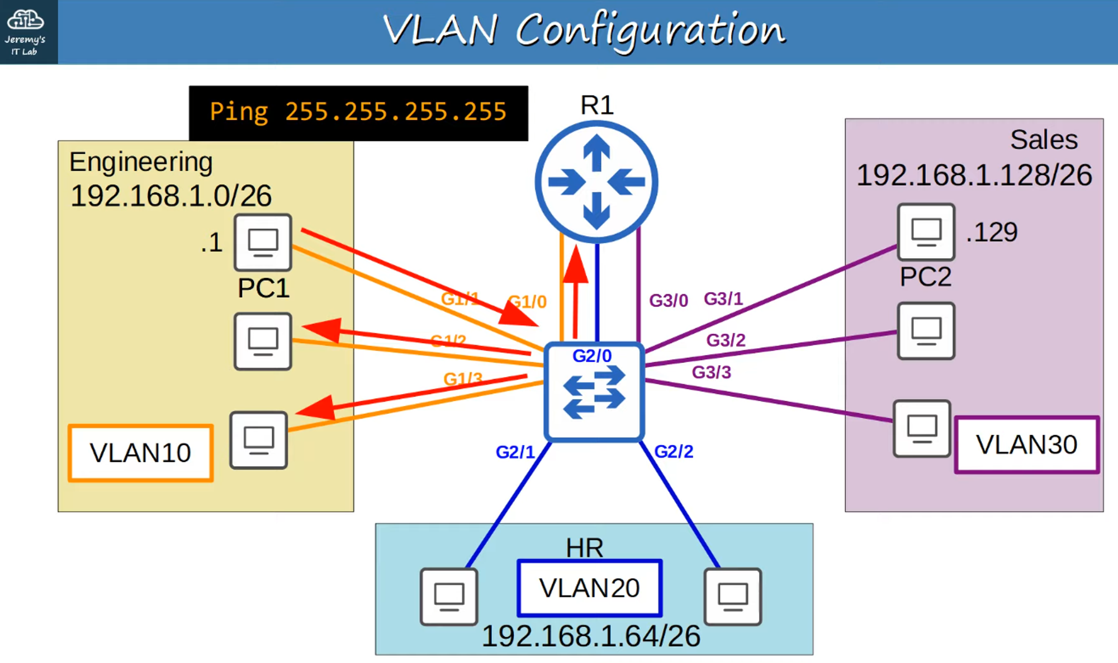

## **ADDITIONAL NOTES**

* VLANs are essential for improving both **network performance** and **security** by separating devices into **logical groups** at Layer 2.
* Always verify VLAN configurations using the #show vlan brief command to ensure proper network segmentation.